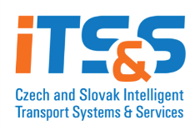




Registration Form/B2B Meetings
Czech-Austrian Forum on Intelligent Transport Systems (ITS)
May 16, 2013
Czech Embassy in Vienna, Penzingerstrasse 11-13

- Yes, I am interested in B2B meetings
Company
Name:
Internet:
Contact Person
Name:
Position in the Company:
Telephone:
E-Mail:

Already engaged in international cooperation? yes no
Company’s current Products / Services/ Activities:

Description of co-operation requested/offered:

Other requirements:

Please fill in the registration form and send it to commerce_vienna@mzv.cz until
May 3, 2013.

